QUESTION 1

INPUT

#include <iostream>

#include <cmath>

using namespace std;

int Armstrong(int num)

{

int left,number;

int count = 0;

int temp = num;

while (temp!=0)

{

temp /= 10;

count++;

}

while (num!=0)

{

left = num % 10;

number += pow(left,count);

num /= 10;

}

return number;

}

int main()

{

int n,number;

cout<<"Enter the number to check => ";cin>>n;

number=Armstrong(n);

if (number == n)

{

cout<<n<<" is the Armstrong number";

}

else

{

cout<<n<<" is not the Armstrong number";

}

return 0;

}

OUTPUT

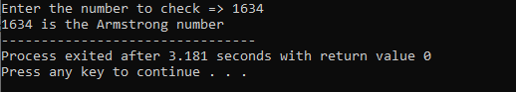

QUESTION 2

INPUT

#include <iostream>

using namespace std;

int main()

{

int n,r,sum=0,lmber;

cout<<"Enter the Number=";

cin>>n;

lmber=n;

while(n>0)

{

r=n%10;

sum=(sum*10)+r;

n=n/10;

}

if(lmber==sum)

cout<<"Number is Palindrome.";

else

cout<<"Number is not Palindrome.";

return 0;

}

OUTPUT

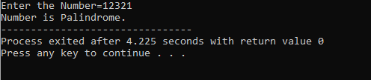

QUESTION 3

INPUT

#include <iostream>

using namespace std;

int main()

{

int a;

cout << "Enter a number: ";

cin >> a;

for (int i = 1; i <= 10; ++i) {

cout << a << " * " << i << " = " << a * i << endl;

}

return 0;

}

OUTPUT

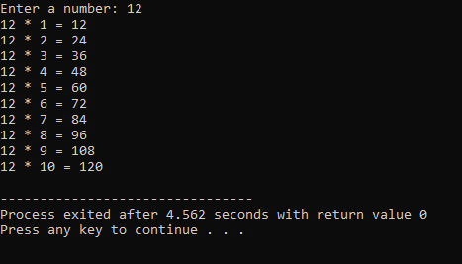

QUESTION 4

INPUT

# include <iostream>

using namespace std;

int coffee=0,tea=0,coke=0,orangejuice=0,order,x=0;

void f1(){

cout <<"THE ORDER NUMBER IS ";

cin >> order ;

if (order==1)

coffee+=1;

else if (order==2)

tea+=1;

else if (order==3)

coke+=1;

else if (order==4)

orangejuice+=1;

else

cout<< "No one is selected" ;

cout <<"IF DO U WANT TO RUN AGAIN PRESS ANY THING ELSE -1:" ;

cin>> x;

}

int main()

{ do{

f1();}while( x!=-1);

cout << "coffee =" <<coffee <<" tea ="<<tea <<" coke =" <<coke << " orangejuice =" <<orangejuice ;

}

OUTPUT

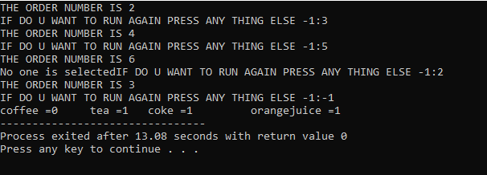

QUESTION 5

INPUT

#include <iostream>

#include <string>

using namespace std;

float input(float & gp);

float point(string gp);

int main()

{

float c1,c2,c3,c4, gp1,gp2,gp3 ,gp4 ;

c1 = input(gp1);

c2 = input(gp2);

c3 = input(gp3);

c4 = input(gp4);

cout << "Your gpa is = "<< (gp1+gp2+gp3+gp4)/(c1+c2+c3+c4)<<endl;

return 0;

}

float input (float & gp){

string g1;

float c1;

cout << "Enter the grade of your subject ";

cin >> g1;

cout << "Enter its credit hours ";

cin >> c1;

gp = point(g1) * c1;

return c1;

}

float point (string gp){

if(gp =="A"){

return 4.0;

}

else if(gp =="A-") {

return 3.67;

}

else if(gp=="B+") {

return 3.33;

}

else if(gp=="B") {

return 3.00;

}

else if(gp=="B-"){

return 2.67;

}

else if(gp=="C+"){

return 2.33;}

else if(gp=="C"){

return 2.0;

}

else if(gp=="C-"){

return 1.67;

}

else if(gp=="D+"){

return 1.33;

}

else if(gp=="D"){

return 1.0;

}

else

return 0;

}

OUTPUT

